- \Service\System settings\Time
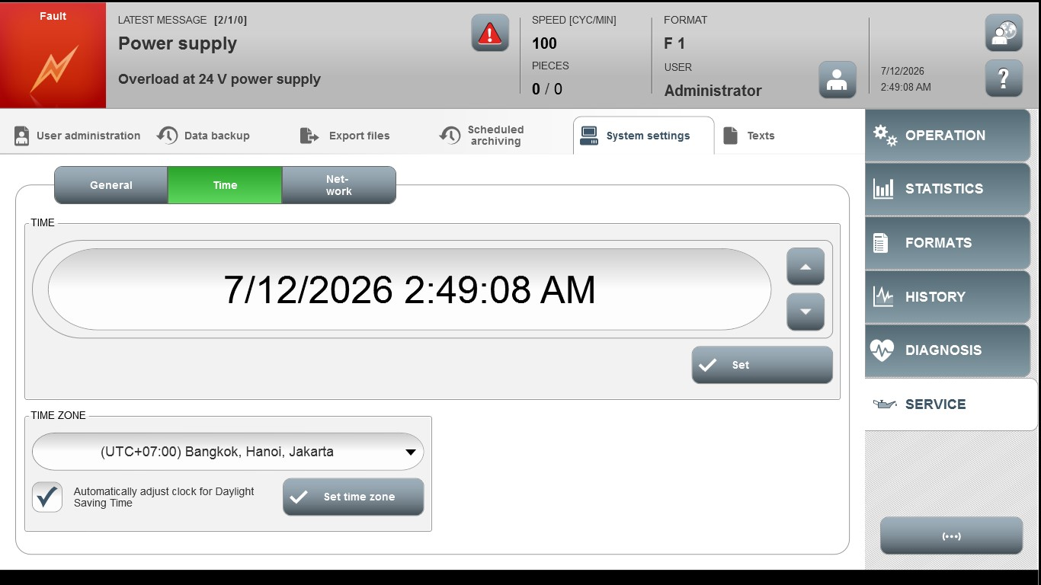
Acceptance criterion | Limits | Pass / Fail: Dev-No. | Date | Initials
Screen matches screenshot | N / A

